Better Impact Rollout Quick Start Guide

We’re so excited to be bringing you a new and improved volunteer database solution through Better Impact! Below you’ll be able to follow steps to help walk you through what the system will look like when you first sign to your existing volunteer profile, and the steps that you will need to take to bring your information up to date. This solution will give us a better opportunity to serve and connect with all 400+ volunteers in our network to a better extent!
In preparation to get you all into the system, we’ve assigned unique usernames and passwords that will be emailed to you. If you don’t see an email from us that means that it might have been sent to a former email of yours, and we need to update that! Please call us to straighten this out at 207-396-6595. If you have the email with your username and password, go ahead and follow the link included in that email. OR – you can access Better Impact from SMAA’s website.

- Logging in for the First Time
We already have user accounts set up for volunteers in the new MyImpact portal, so click on “Log in to your account” and enter the credentials from the email we sent out.
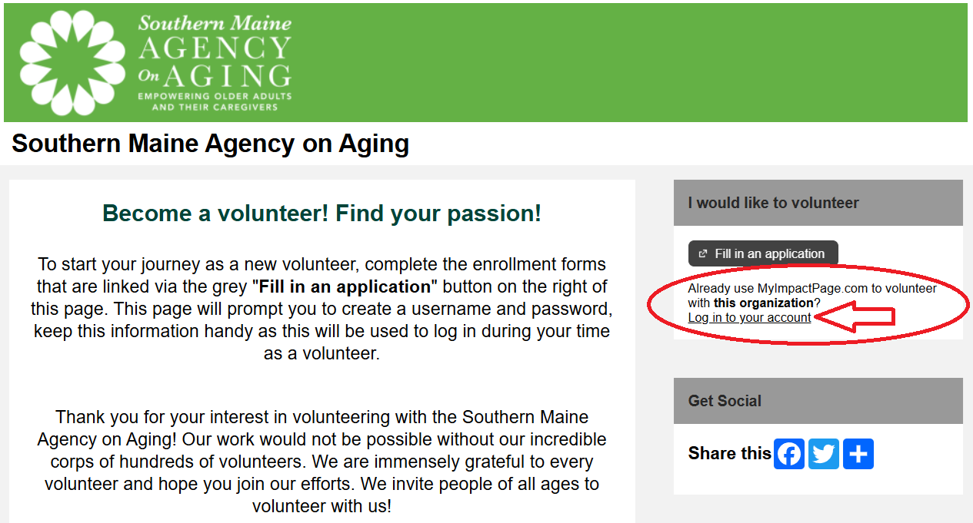

One thing you can do to make things easy on yourself next time you log in is bookmark this page in your web browser, and update your username and password! Both can be changed under MY PROFILE, but while you’re at it verify your contact information is all up to date!

- Updating Your Profile
Your Username can be changed on this page, and you can also opt to upload a personal photo! This is totally optional, but is helpful for SMAA staff who might be in the system to pair names with faces. It also helps us to create and update your volunteer ID badges. You’ll have to upload from an image file on your computer or smart device, but the picture can be removed or replaced at any point from the Better Impact My Profile - Contact Information page.
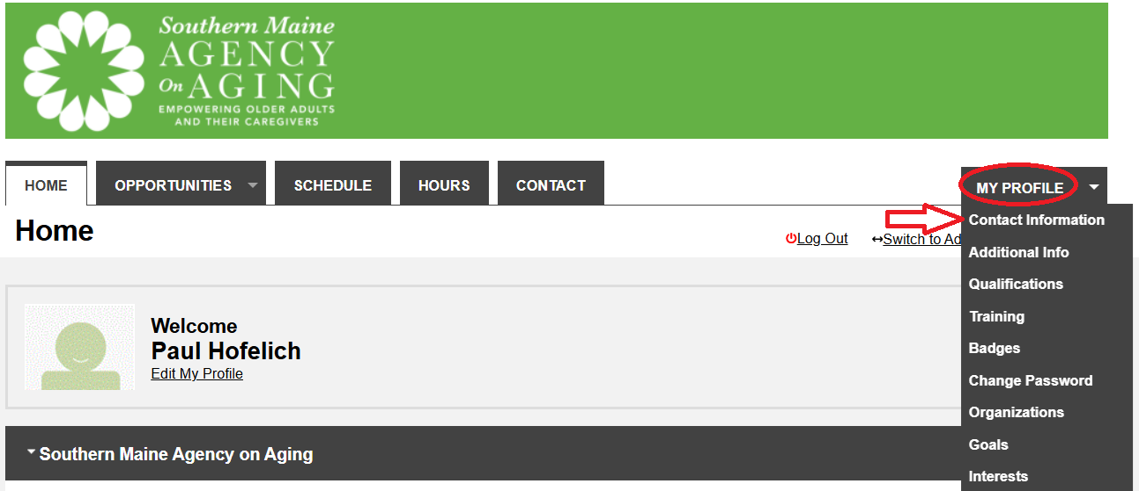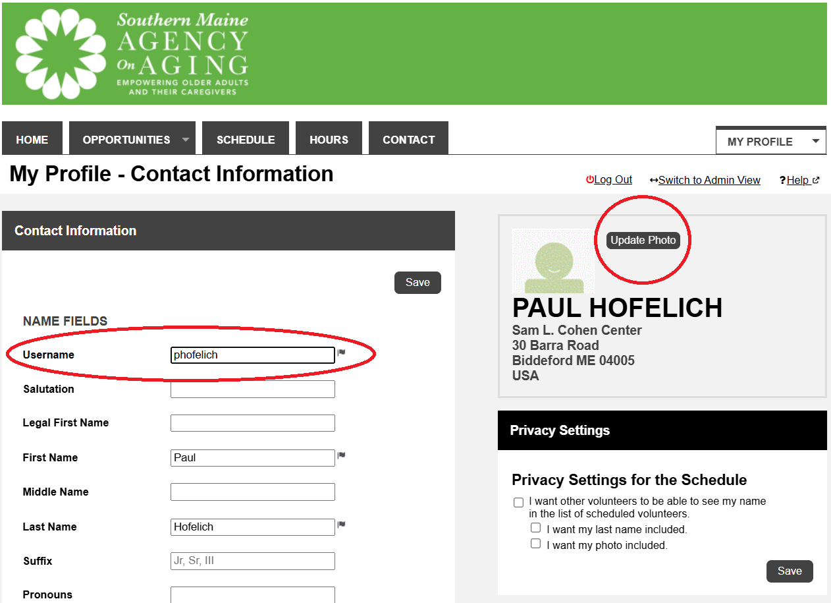
Below is an example of a photo that I uploaded to my profile! If you run into issues you can easily remove or rotate the photo to display correctly.
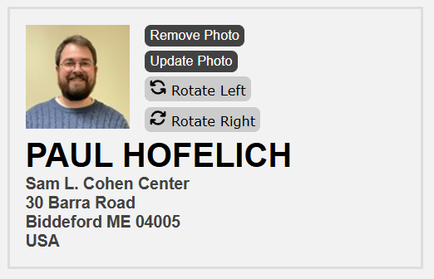

- Changing Your Password
To change your password, hover over MY PROFILE once again and select Change Password. If you ever forget your password or username there are steps on the login screen to reset the password on your own through the “Forgot your username or password?” feature. I know many of you have been asking for a way to easily reset your password on your own!

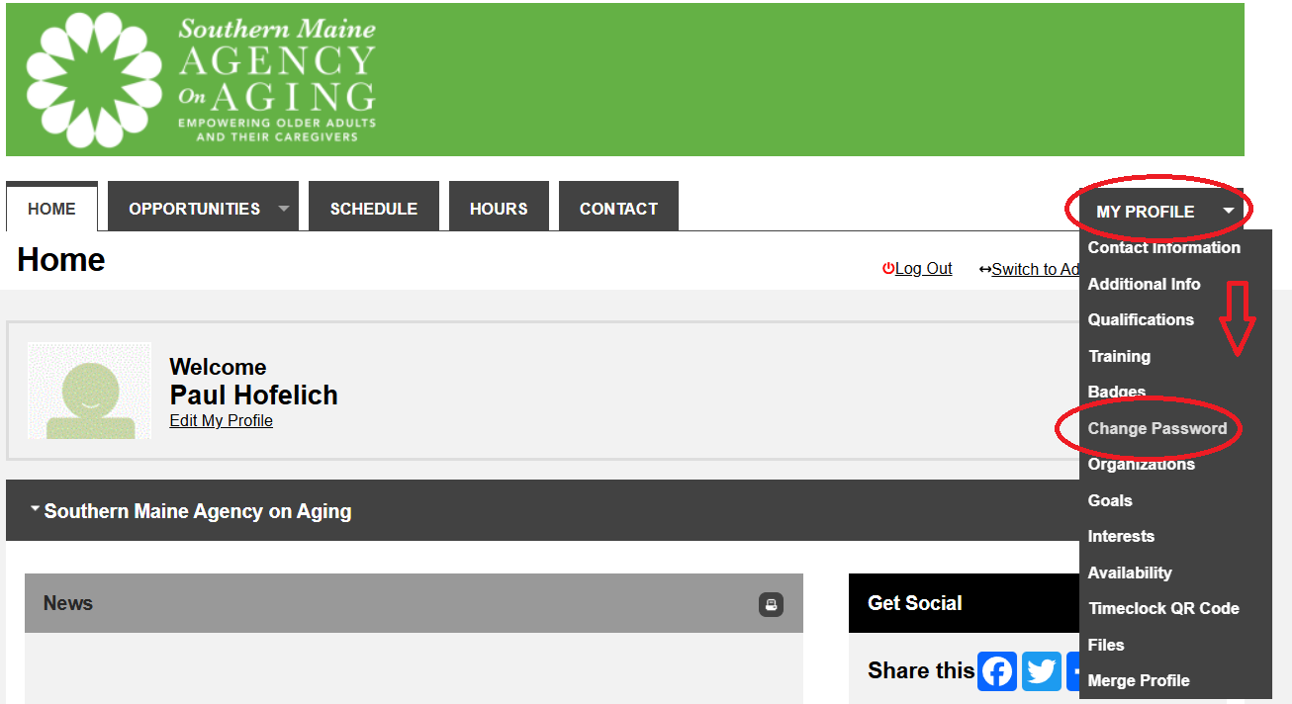
- Updating your Profile, Emergency Contact, & Demographic Information
We were lucky enough to be able to migrate everything from our former database so your existing contact information, volunteer assignment, and volunteer hours will all be baked into this new platform – please take some time to look over your profile and make sure everything looks up to date. Under MY PROFILE click Additional Info to update your Emergency Contact Information & Demographics & Details. The Additional Info also has a place where you can share more about yourself called Let’s get to know you a bit better!; here you can share the reason you volunteer, connections that you have to other local partners, availability, and any past career or volunteer history that you’d like us to know about you! Lastly, under Odds & Ends, you can check the box to automatically opt out of SMAA’s media release – this will take you off our list of people to ask for testimonials.

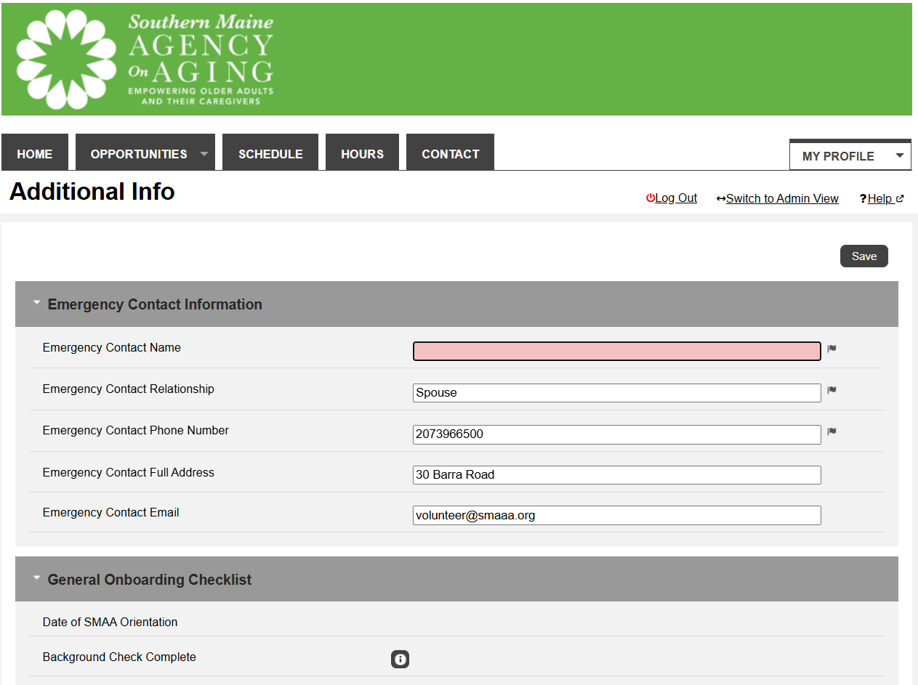

- Signing the Handbook Acknowledgment
Next thing you’ll want to do is review our updated 2025 SMAA Volunteer Handbook and sign our Acknowledgment Form stating you’ve reviewed it – SMAA is required to collect these acknowledgement signatures from our volunteers each year. You can find the Acknowledgment back on the MyImpact HOME page and scrolling down to the News section. Moving forward after this initial sign off, we’ll have you access and sign this document annually, with rollout of a future handbook updates including a video highlighting any important changes from year to year!

- Logging Your Volunteer Hours
The last thing you’ll want to do is going to be logging your hours. If you’ve gotten to this point you’ve spent some time watching the video or following along in this sample document – let’s put those hours in the system! Click on the HOURS at the top of the page any time you want to log your hours. We should have your volunteer role set up under the Activity drop down box, based on placements in our former database – however we recognize that there may have been some errors in this migration process, so please contact us and let us know if:
- you see the WRONG VOLUNTEER ACTIVITY on your profile
- you see an OUTDATED VOLUNTEER ACTIVITY on your profile
- you see NO VOLUNTEER ACTIVITIES on your profile
- OR any combination of the above!

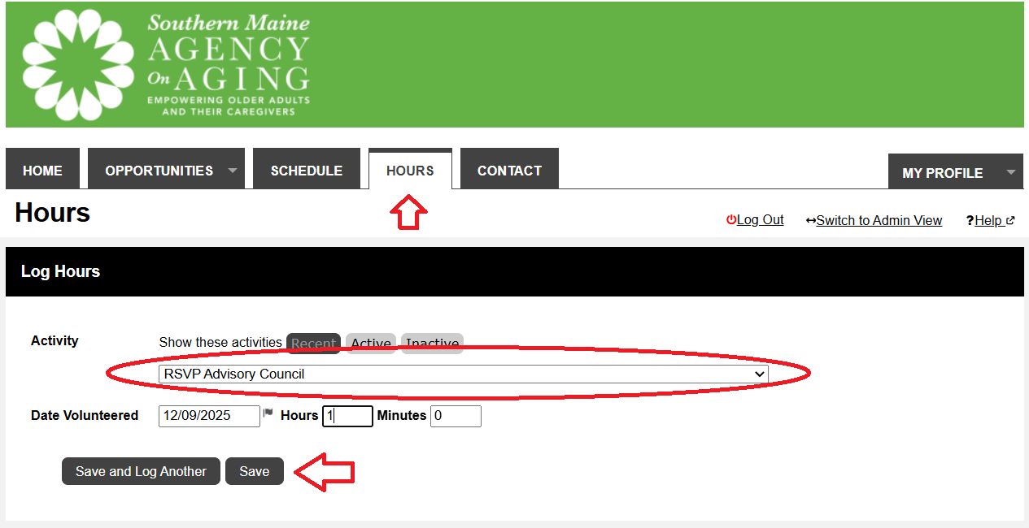

If you see your current activity log the time that you spent training today under the activity that you spend most of your time involved with. Moving forward, we ask that you log your total volunteer hours at least once a month, however you may want to consult your direct program lead/supervisor first if there is a simpler system in place that tracks the hours you serve (i.e. the Mon Ami System for Phone Pals Volunteers or monthly hours sheets for Meals on Wheels Volunteers).

- Office Hours for Assistance!
We’ll also be around this month for additional support both virtually and at a SMAA office near you! These office hours sessions are open to anyone at any point within the times listed, we’ll be there with laptops to help you through this process!

Virtual: Thursday, 1/8 from, 9:30-10:30
Join the Virtual Office Hours on 1/8 from

Or join us in person, close to home! We'll be in:

Portland on Tuesday 1/13, 2:00pm-4:00pm
2320 Congress Street, Portland, ME 04102

Biddeford (Sam L Cohen Center) on Wednesday, 1/21, 9:00am-11:00am
30 Barra Road, Biddeford, ME 04005

Springvale on Monday, 1/26 10:00am-12:00pm
21 Bradeen Street, Springvale, ME

Thank you so much for your part in making this new database what we need it to be! We appreciate everything you do and will look forward to integrating new features as we explore all that is possible with Better Impact’s dynamic platform!
If you have any questions, or require assistance with this process, please do not hesitate to reach out to us at any time. You can reach Paul & Meg, your SMAA Volunteer Services Team, at Volunteer@smaaa.org or 207-396-6595!

Thank you for ALL you do!
Sincerely,
Your SMAA Volunteer Services Team
Meg Barhite, Volunteer Services Director & Paul Hofelich, Volunteer Coordinator
Volunteer@smaaa.org / 207-396-6595

